EventFlow: COS 214 Practical 3

Vimbai Chivunga u25136608
Chelsy Whata u25657764
Sudud Abughazaleh u25282728

Event name and description
Event Name: EventFlow: Astral Fields Festival
Event Description: The Astral Fields Festival is a multi-zone outdoor music and entertainment festival managed by the central Festival Control system. Structure & Capacity: The festival is organized into distinct functional areas—including the Plaza Zone, Food Court, River Zone, and Camping Zone—with an aggregate capacity of 12,000 attendees for the overall grounds and a current configured capacity across active units. Facilities & Attractions:Live music stages featuring performances like "The Falling Orbit" at the Aurora Stage and "Echo Bay Strings" at the River Stage. Ticketing and entry control managed through admission points such as the North Gate handling "Weekend Pass" holders. Food and beverage concessions including the Taco Vendor (street tacos & limeade) and Coffee Vendor (espresso & pastries). Essential event infrastructure comprising a Medical Team (general first aid), River Info Desk, Camp Office, Shuttle Stop transportation (River Loop), a Backup Power Station, and perimeter surveillance by the SecurityPost. Operational Flow: The event is driven by central broadcast notices that coordinate site-wide operations, from opening gates and adjusting headline performance schedules to managing crowd capacities, handling severe storm weather alerts, issuing temporary pauses, and executing end-of-night shutdowns.

UML Class Diagram
The completed class diagram below shows the abstract base classes (EventComponent, Observer, Subject, Notice) with their operations, the inheritance relationships to concrete classes, the Composite ownership association (filled diamond, 0..* children, owned), the Observer registration association (open arrow, 0..* observers, explicitly non-owning), the non-owning root association from EventControl to EventGroup, and the eight concrete leaves and eight concrete notice types. Every abstract base declares a virtual destructor.
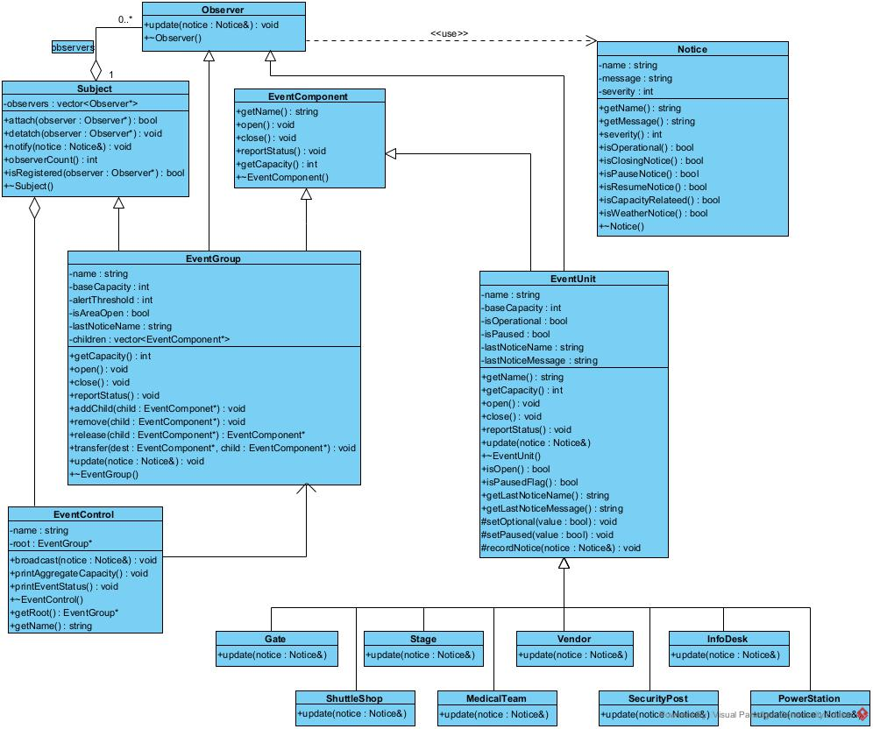

Design Rationale

(a) Why the Composite is a genuine part-whole tree
EventGroup does not merely group EventComponents for convenience of iteration - it recursively delegates the same operations (open, close, reportStatus, getCapacity) to every child, so a zone's aggregate capacity is always the sum of its own base capacity plus every descendant's capacity, computed on demand rather than cached and kept in sync by hand. Because EventGroup itself implements EventComponent, a group can contain other groups (Food Court inside Plaza Zone) as well as leaves, giving arbitrary depth rather than a fixed two-level structure. This satisfies the defining property of Composite: the client (main(), EventControl) manipulates a single unit and an entire subtree through the exact same interface and never needs to know which one it is holding.

(b) Why Observer is required rather than direct hard-coded calls
EventControl and the intermediate EventGroups do not know, at compile time, the concrete set of units that must react to a given notice - that set changes at runtime (SecurityPost is attached, detached and re-attached during the demonstration; Coffee Vendor is transferred between zones and carries its observer registration with it). A hard-coded sequence of calls in EventControl would have to name every concrete leaf type and would break every time a unit was added, removed or moved. Observer replaces that with a single loop over a registration list that is built and modified entirely at runtime, so EventControl and EventGroup depend only on the abstract Observer interface, never on Stage, Gate, Vendor, etc. by name.

(c) Who owns event components
EventGroup owns every EventComponent in its children vector. add() transfers ownership into a group; the group's destructor deletes every component still present in that vector when the group itself is destroyed, so deleting the root releases the entire owned subtree exactly once. Ownership can move between groups at runtime: release() removes a child from a group's children vector and returns it without deleting it, and transfer() combines release() on the source with add() on the destination so a component is owned by exactly one group at any moment and is never deleted twice. EventControl and the client (main()) hold only a non-owning EventGroup* to the root and never delete event components themselves except through the root's destructor.

(d) Who owns (or does not own) observer references
Subject stores observers as raw, explicitly non-owning pointers. This is necessary because an object registered as an observer is frequently owned elsewhere for a completely different reason - a Vendor, for example, is owned by its EventGroup (Composite ownership) while simultaneously being registered as an observer of that same group (Observer registration). If Subject deleted its observers, this would either double-delete objects also owned by a Composite parent, or would incorrectly take ownership of monotask observers such as SecurityPost that the client owns directly and outlives any particular registration. The two relationships are kept independent: attach()/detach() only ever change the registration list, never call delete, and object lifetime is managed entirely through the Composite ownership tree or by the client.

(e) Why EventGroup being both Subject and Observer is not a misuse of either pattern
EventGroup implements Observer so that it can receive a notice cascading down from its own parent, and implements Subject so that it can then notify its own children. These are two distinct collaborations with two distinct sets of correspondents: as an Observer, EventGroup's correspondent is whatever registered it (its parent group, or EventControl for the root); as a Subject, EventGroup's correspondents are its own registered children, which is a completely different set of objects for a different reason. update() in EventGroup demonstrates the separation directly: it first performs the Observer reaction (record the notice, check the capacity threshold), and only then calls notify() to perform the Subject role. Nothing here collapses the two patterns into one - a class simply sits at the boundary between two independent one-to-many relationships, which is exactly the situation the practical brief anticipates when it says a class may participate in more than one pattern collaboration for different reasons.

Composite Object Diagram

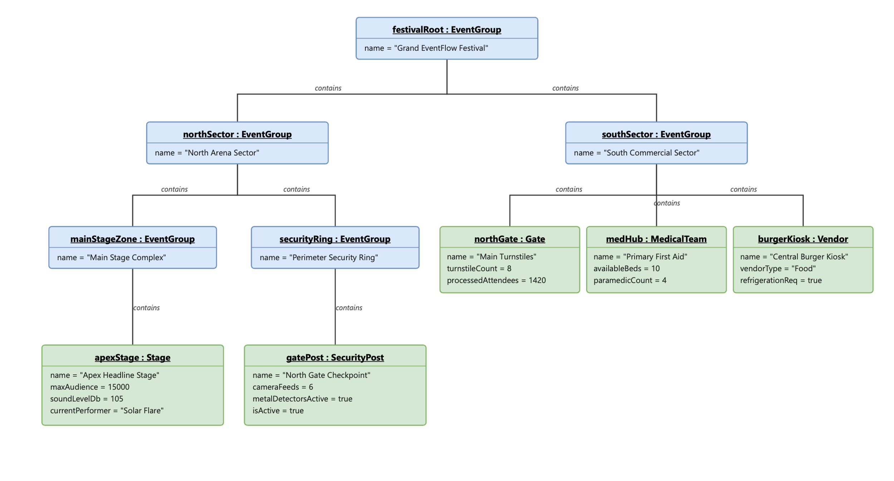

Event rules and original features

Event Rules
Each concrete unit overrides update(Notice) with its own reaction logic. EventControl and EventGroup call notify() on their observer list without any knowledge of which concrete leaf types exist — the differing behaviour below is achieved entirely through polymorphism, not type checking in a controller.
Safety & Emergency Precedence (WEATHER_ALERT / EVACUATE):
Stages halt live sets and cut audio power; Gates cease processing entries; SecurityPost initiates emergency perimeter protocols and clears exit paths; MedicalTeam activates triage; Vendors suspend service and shut down gas cooking.
Capacity Threshold Enforcement (CAPACITY_WARNING):
Gates enforce crowd-holding procedures at access points; non-essential concession services such as food and beverage Vendors are automatically suspended; Stage, MedicalTeam and SecurityPost remain fully operational.
Pause & Resumption Lifecycle (PAUSE / RESUME):
Pause notices place active units — Stage, Gate, Vendor — on operational hold. Resumption notices evaluate each unit's current state independently and restore normal performances, sales and admissions without requiring any structural rebuild of the composite tree.

Original Features
1. Coupled Assembly with Auto-Registration: When EventGroup::add() is called, the parent group both adopts ownership of the component and automatically registers it into its local observer subscription list in the same call. This coupling stays safe from a god-object standpoint because it lives entirely inside EventGroup's own add() operation — no external coordinator decides registration on the composite's behalf.
2. Independent Monotask Observers: Out-of-tree monitoring units, such as a SecurityPost stationed outside the spatial hierarchy, can subscribe directly to EventControl to receive site-wide alerts without being owned by any EventGroup. This is safe because EventControl only maintains a flat Subject/Observer list — it doesn't need to know or care whether an Observer also happens to sit in the Composite tree, so no new responsibility is added to any single class.
3. Decibel Limiter (Stage): Stage automatically throttles its own amplifier gain if sound output exceeds 100dB, without needing a coordinator command. This logic lives entirely inside Stage's own state and behaviour, so no central class needs to know about it, keeping the decision distributed rather than centralised.

SD1 Building and registering of the event
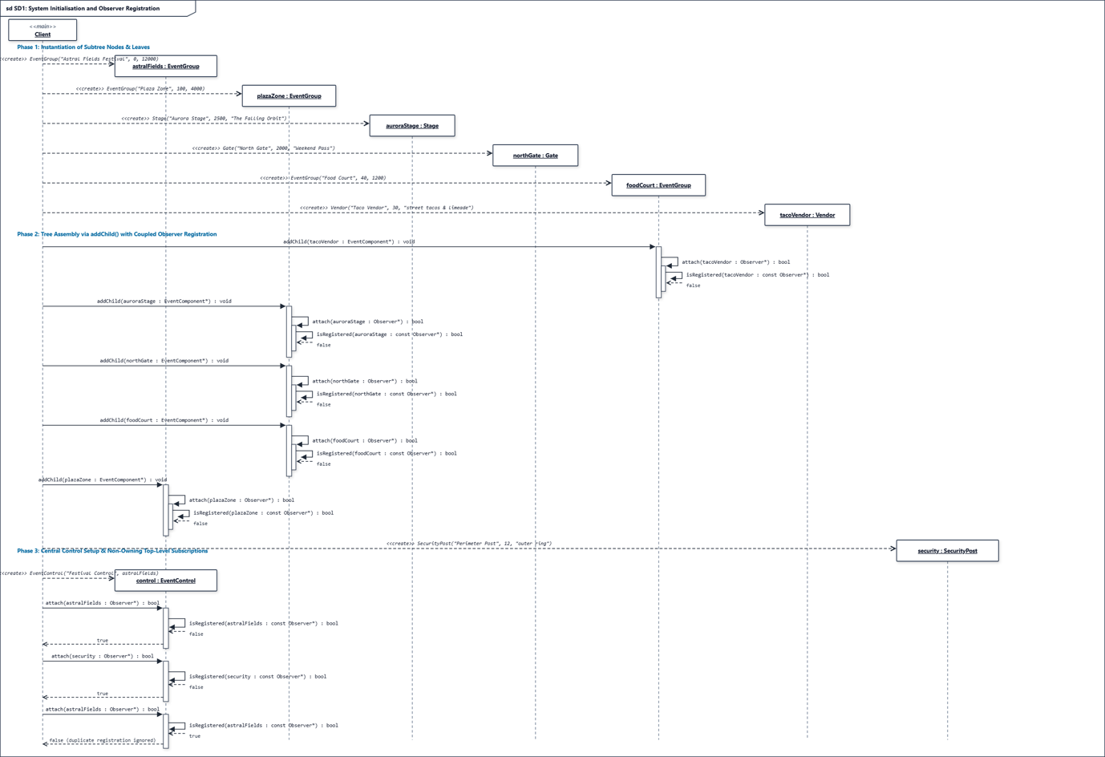

SD2 Cascading event notification
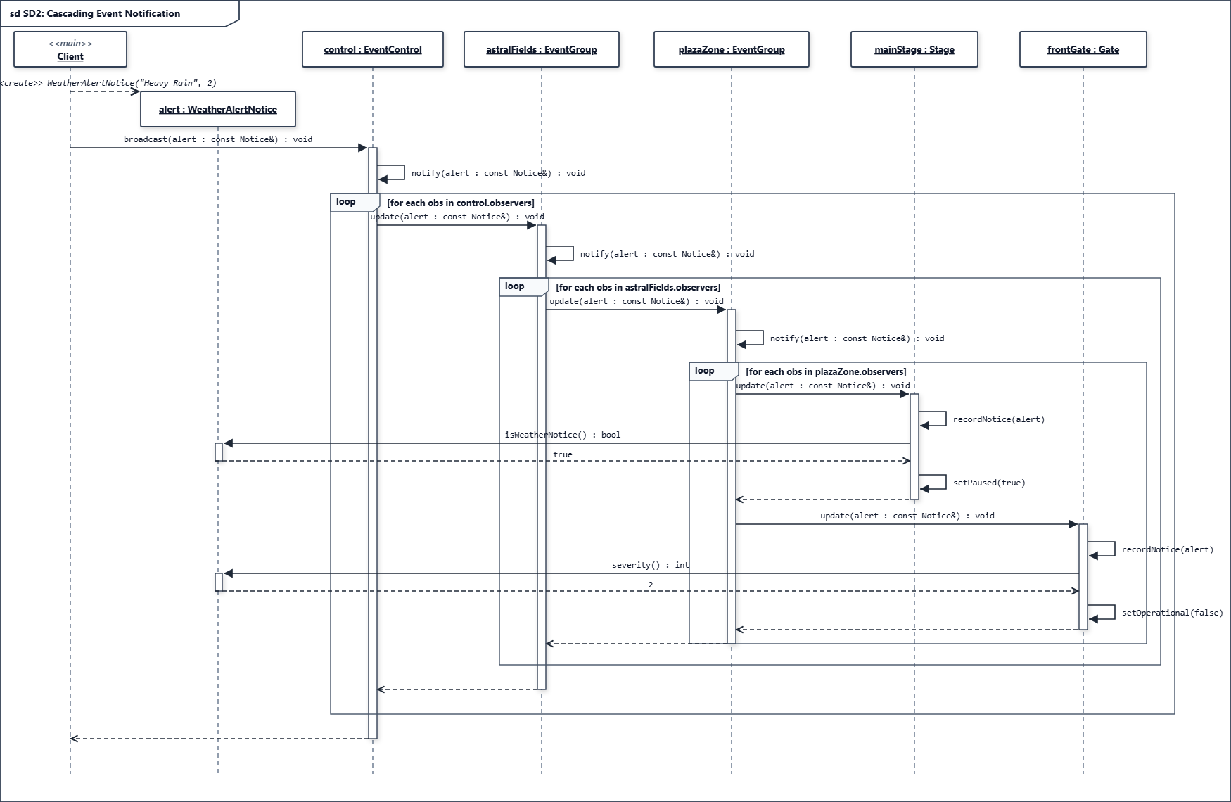

SD3 Conditional event response and Composite behaviour
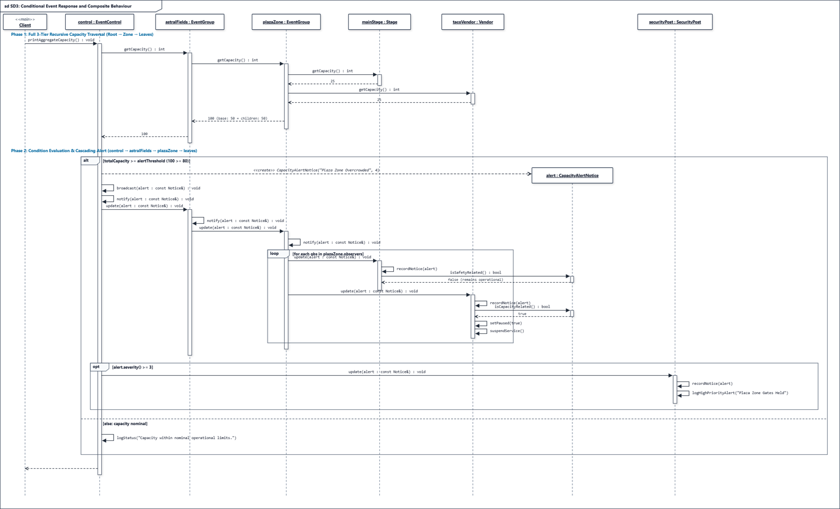
SD4 Signature event scenario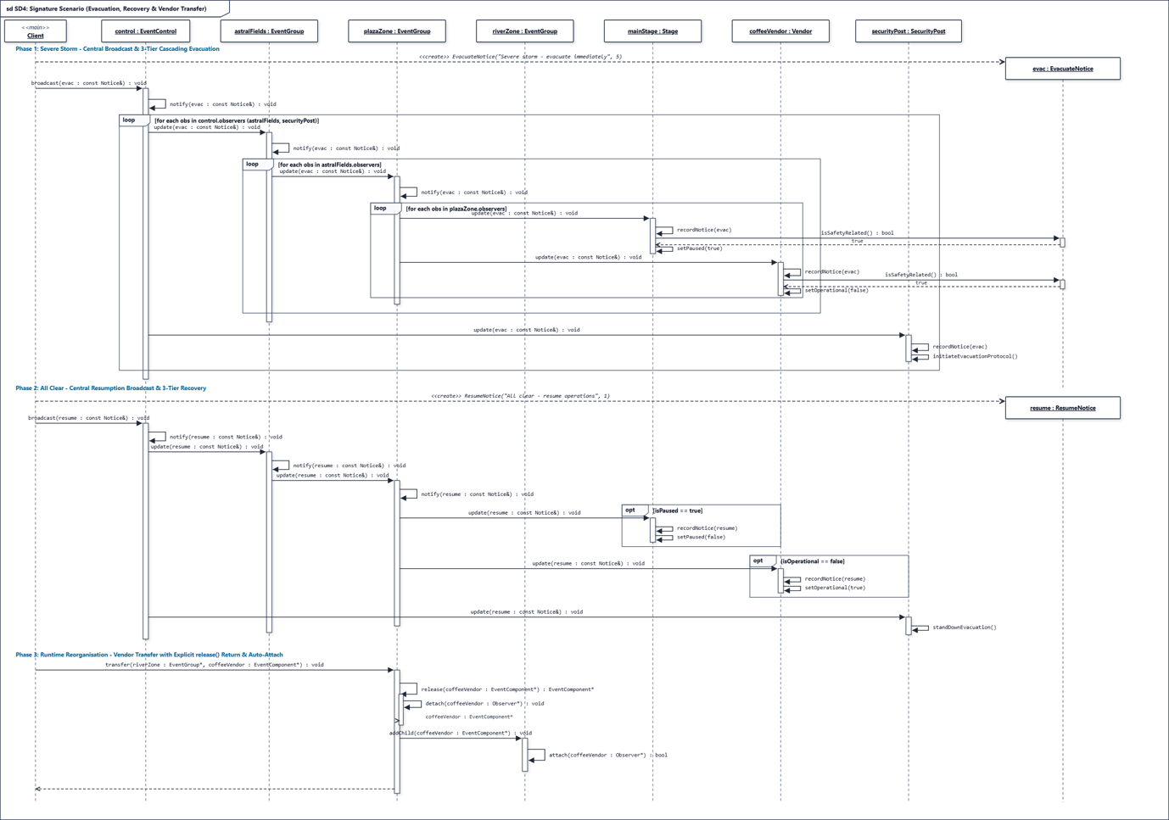

Doxygen, landing page:
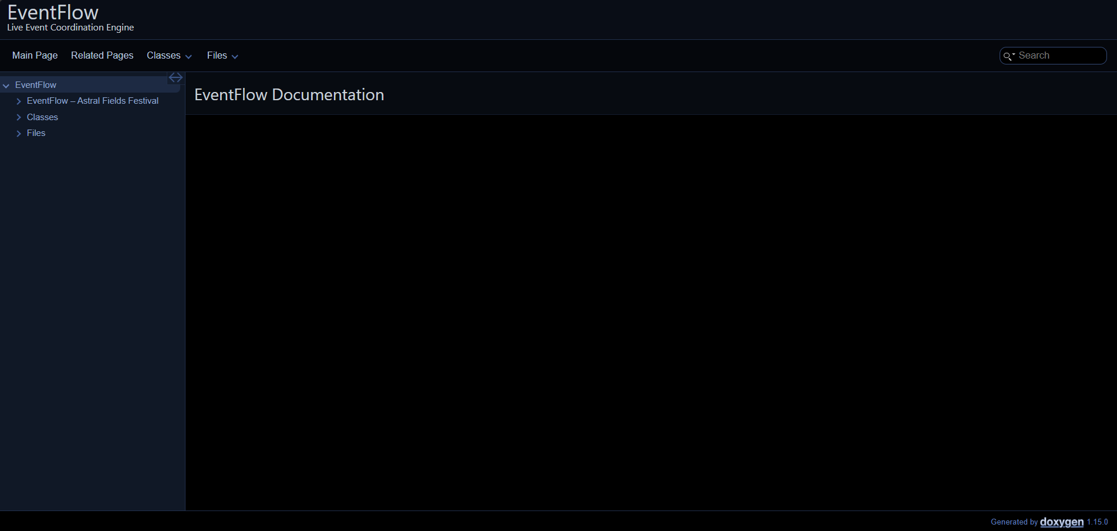

Github repo link:
https://github.com/vimbaichivunga/COS-214-Practical-3

GitHub Workflow Reflection

Teamwork Division and Branching Strategy:
- Chelsy: Responsible for Task 1 and Task 5. Worked primarily on the feat/task1-architecture and docs/task5-sequence-diagrams branches.
- Sudud: Responsible for Task 2, Task 4, and Task 7 as well as pulling everything to the main branch. Developed on Task-2---Composite-Event-Structure and feat/task4-event-rules.
- Vimbai: Responsible for Task 3, Task 6, and Task 8. Developed on feat/task3-observer-system and feat/task6-8-integration.

Integration Workflow and Conflict Mitigation:
Development progressed asynchronously using GitHub Pull Requests. Each member developed their allocated components on isolated feature branches. Before opening a PR to merge into main, team members rebased against the latest main branch locally to resolve header dependency discrepancies early. It was also made sure that no file was pulled into main twice if it was used in more than one task.

Key Commits Demonstrating Meaningful Collaboration:
Our commit history reflects continuous, incremental integration over time rather than a single bulk upload:
1. Commit "feat(composite): implement recursive destruction and leaf unit slots": Established the core EventComponent abstraction, ensuring that post-order memory deallocation in EventGroup released child nodes without memory leaks.
2. Commit "feat(observer): add cascading push-notification pipeline across composite layers": Integrated the Subject and Observer registries, allowing EventGroup to act as an intermediary node forwarding alerts to lower-tier leaves.
3. Commit "refactor(transfer): implement atomic ownership transfer and observer re-registration": Connected the structural composite removal logic from Task 2 with the dynamic unit reorganisation requirements of Task 4.

Task 1:

Event Concept
Astral Fields Festival is a three-day outdoor music and arts festival held across a single large venue. The festival is organised into physically separate zones that each need to be opened, closed, reported on and sized in the same way, while individual operational units inside each zone (stages, gates, vendors, staff teams) must react differently to the same event-wide announcement. This mix of uniform part-whole structure and heterogeneous reaction to shared notices is exactly what EventFlow is built to coordinate.
The venue is represented as a single root event ("Astral Fields Festival") containing three top-level zones: the Plaza Zone (the main stage area), the River Zone (a secondary stage and transport hub) and the Camping Zone (overnight accommodation and support services). The Plaza Zone itself contains a nested Food Court sub-zone, giving the tree three levels of Composite nesting below the client/root boundary (root -> zone -> sub-zone -> unit), as well as units placed directly under a zone (root -> zone -> unit).

At least three kinds of grouping/area appear in the Composite tree:
The root event (Astral Fields Festival) - the top of the tree, associated with EventControl but not owned by it.
Top-level zones (Plaza Zone, River Zone, Camping Zone) - each an independently opened/closed/reported-on area with its own capacity threshold.
A nested sub-zone (Food Court) - a Composite contained inside another Composite, proving the tree is genuinely recursive rather than exactly two fixed levels.

At least five (in fact eight) concrete kinds of event unit appear as leaves:
Stage - hosts a performance; pauses on safety notices and resumes on instruction.
Gate - admits attendees by ticket type; stops admitting on safety or closing notices.
Vendor - sells food/drink; suspends service on safety or capacity-related notices.
InfoDesk - guides visitors; deliberately stays open through safety notices.
ShuttleStop - runs a transport route; reroutes rather than stopping on a weather notice.
MedicalTeam - provides first aid; stays operational through every safety notice.
SecurityPost - patrols a sector; can register with EventControl directly, outside the ownership tree, to show observation does not require containment.
PowerStation - supplies backup power; enters a low-power mode on a weather notice (an original feature not required by the brief).
A central control room, EventControl, issues notices - opening, schedule changes, capacity warnings, weather alerts, pauses, resumptions and evacuation orders - that cascade down through the zone tree to whichever units are currently registered to receive them, and reorganisation (e.g. reassigning a vendor from one zone to another) can happen at runtime without breaking either the ownership tree or the notification registrations.
GoF Participant Mapping (Observer and Composite)
Several classes participate in more than one collaboration. Each role is listed on its own row and explained separately, as required.

Class | GoF Role(s) | Pattern | Collaboration this role applies to
EventComponent | Component | Composite | Common interface implemented by both EventUnit and EventGroup so a client can open/close/report/size any part of the event tree without knowing whether it holds a single unit or a whole subtree.
EventUnit | Leaf | Composite | Represents a single operational unit (Stage, Gate, Vendor, InfoDesk, ShuttleStop, MedicalTeam, SecurityPost, PowerStation) with no children of its own.
EventUnit | Concrete Observer | Observer | Reacts to a pushed Notice via update(), applying the shared open/close/pause state machine and, in each concrete subclass, an event-specific rule (e.g. Stage pauses, Vendor suspends service).
EventGroup | Composite | Composite | Represents a zone/area that holds and recursively operates on child EventComponents (open, close, reportStatus, getCapacity).
EventGroup | Concrete Observer | Observer | Receives a Notice pushed from its own parent (or from EventControl if it is the root) and records it as the group's last notice.
EventGroup | Concrete Subject | Observer | Having received a notice as an Observer, EventGroup immediately acts as a Subject and calls notify() to cascade that same notice to its own registered child observers - this is what makes multi-level cascading possible.
Subject | Subject | Observer | Abstract registration/notification interface: attach(), detach(), notify(), and the non-owning observer list.
Observer | Observer | Observer | Abstract reaction interface: update(Notice&).
EventControl | Concrete Subject | Observer | The top-level broadcaster. Client code calls broadcast(notice), which calls notify() to push the notice to every registered top-level observer (normally the root EventGroup, plus any monotask observers such as SecurityPost).
main() (Client) | Client (Composite) / Client (Observer) | Observer and Compositr | Builds the composite tree with add(), wires up observer registrations with attach(), and drives the scenario through EventControl.broadcast().

Task 2

2.4)
Why the subtree is released exactly once: EventComponent has a virtual destructor, so delete on a base pointer always resolves to the correct derived destructor. EventGroup's destructor iterates its children container and deletes each one; if a child is itself a Composite, this recurses automatically. This works safely because every component is owned by exactly one parent at a time (never referenced from two containers), making the tree a true tree with no cycles or shared nodes — so one recursive walk from the root visits, and destroys, every node exactly once.
Transfer ownership rules: Transferring a component calls remove() on the old parent (erases the pointer, does not delete) before add() on the new parent, so the component is never owned by two composites at once and never left dangling. Only the owning composite may delete a component — no other class holds that authority. If the component is also a registered Observer, detach()/attach() are called alongside the transfer so ownership and observation stay consistent. This prevents double deletion structurally: at any instant, exactly one owner exists.

Task 3:
3.1)
The Subject abstract class manages dynamic runtime registration of observers using a standard vector container. To ensure sensible runtime behaviour, explicit policies are enforced for duplicate attachments and unregistered detach attempts:
Duplicate Registration Policy: If attach(Observer* observer) is invoked with an observer pointer that is already present in the registration list, the call is ignored. This guarantees that duplicate notifications are not issued during event broadcasts and prevents array corruption or duplicate handling logic in concrete components.
Unregistered Detach Policy: If detach(Observer* observer) is called for an observer pointer that does not currently exist in the registration list, the operation completes as a silent no-op. No exceptions are thrown, and system state remains unaffected.
Safe Iteration Guarantee: To prevent iterator invalidation or undefined behavior when an observer attaches or detaches itself during an active notify() broadcast loop, the Subject iterates over a snapshot copy of the internal registration list.
3.2)
In a complex event-driven architecture, improper lifetime management leads to dangling references and severe memory faults. The following policies guarantee lifetime safety:
Non-Owning Reference Strategy: Registrations operate strictly on a non-owning observer model. The Subject maintains pointers to Observers for notification purposes but does not claim ownership or manage memory allocation/deallocation for registered observers.
Self-Detachment Responsibility: To guarantee that subjects never hold dangling pointers, concrete observers must unregister themselves (detach) from all active Subject instances in their destructors prior to memory release.
Hierarchical Lifetime Ordering: Within the Composite hierarchy, parent components manage child component lifecycles deterministically. Standalone, out-of-tree observers (such as SecurityPost) are explicitly cleanup-managed at the client/driver level (main.cpp), ensuring clear ownership boundaries.
3.3 & 3.4)
The implementation defines seven concrete Notice classes derived from the base Notice class, assigned explicit numeric severities (0 to 2) and boolean categorization methods:
Operational & Lifecycle Notices: OpenNotice (Severity 0, isOperational() = true) and CloseNotice (Severity 1, isClosingNotice() = true).
Timeline Notices: ScheduleChangeNotice (Severity 0, custom update handling across units).
Capacity-Related Notices: CapacityAlertNotice (Severity 1, isCapacityRelated() = true).
Safety & Status Notices: WeatherAlertNotice (Severity 2, isSafetyRelated() = true, isWeatherNotice() = true), PauseNotice (Severity 1, isPauseNotice() = true), ResumeNotice (Severity 0, isResumeNotice() = true), and EvacuateNotice (Severity 2, isSafetyRelated() = true, isClosingNotice() = true).
Cascading Architecture (3 Runtime Levels):
The EventControl hub dispatches notifications to top-level EventGroup nodes (Level 1: Root Festival). The notification recursively cascades down to intermediate sub-groups (Level 2: Zones/Plaza), and finally reaches concrete leaf units (Level 3: Stages, Vendors, Gates), allowing each node to react polymorphically based on its domain role.
3.5)
The implementation utilizes the Push Model for event updates.
Architectural Trade-Off Analysis:
Push Model (Selected): The Subject encapsulates full contextual detail into a Notice object and passes it directly as a parameter during the update(const Notice& notice) call. This decouples the Observer from needing a direct reference back to the Subject, eliminating bidirectional coupling and optimizing execution speed during high-frequency emergency broadcasts.
Pull Model (Alternative): The Subject notifies observers with a minimal trigger or passing a reference to itself (Subject*), forcing observers to explicitly query ('pull') the required state via getter methods. While offering flexibility if observers only care about small state slices, it increases coupling and introduces additional function call overhead across cascading trees.
Transferred State & Payload Information:
During every update call, the exact state transferred inside the Notice payload includes:
Notice Name / Category: Identifies the exact event type (e.g., Open, ScheduleChange, CapacityAlert, WeatherAlert, Pause, Resume, Evacuate).
Message Payload: Human-readable contextual description explaining the broadcast cause.
Classification Flags: Categorical flags (isSafetyRelated(), isCapacityRelated(), isWeatherNotice(), etc.) that allow concrete units to execute immediate polymorphic filtering without runtime type inspection .

Task 4

4.1)
Each concrete unit overrides update(Notice) with its own reaction logic. EventControl and EventGroup simply call notify() on their observer list without any knowledge of which concrete leaf types exist — the differing behaviour below is achieved entirely through polymorphism, not type checking in a controller.
WEATHER_ALERT: Stage pauses performances and cuts audio power; Gate holds incoming entry; MedicalTeam activates emergency triage; Vendor shuts down gas cooking; SecurityPost locks external barriers.
CAPACITY_WARNING: Gate throttles turnstiles to restrict entry; SecurityPost reinforces bottlenecks; Stage, Vendor, and MedicalTeam remain operational.
EVACUATE: Gate opens all turnstiles for free exit; Stage stops audio to broadcast alarms; Vendor terminates sales immediately; SecurityPost clears exit paths; MedicalTeam deploys outside the perimeter.
SCHEDULE_CHANGE: Stage shifts performer timetables; Vendor extends service hours; Gate extends entry deadlines; SecurityPost and MedicalTeam continue normal shifts.
RESUME: Stage restarts music; Gate re-enables scanning; Vendor restores power; SecurityPost and MedicalTeam return to standard readiness.

4.2)
To relocate medHub (MedicalTeam) from southSector to northSector safely, removal and re-registration are both performed by pointer, never by name, to avoid relying on string comparison as a stand-in for type identification:
Deregister Observer: southSector->detach(medHub); (prevents dangling callbacks)
Release Ownership: EventComponent* unit = southSector->remove(medHub); (removes from vector by pointer, without deleting)
Assume Ownership: northSector->add(unit); (transfers memory lifecycle to the new composite)
Register Observer: northSector->attach(medHub); (links to the new notification channel)
Ownership and Observer registration are updated as two separate steps because they represent two separate relationships in the design; a transfer is only complete once both are consistent.

4.3)
Guarded alt fragment: [getCapacity() >= MAX_CAPACITY] → Gate blocks entry; [else] → Gate admits attendees.
Guarded opt fragment: [isOutdoor == true] → Stage executes pausePerformance() during a WEATHER_ALERT.

4.4)
Decibel Limiter (Stage): Automatically throttles amplifier gain if sound output exceeds 100 dB, without needing a coordinator command. This logic lives entirely inside Stage's own state and behaviour, so no central class needs to know about it, avoiding a god object.
Throughput Throttle (Gate): Queries its parent composite to balance queues across adjacent turnstiles when entry limits are reached. The parent Composite only answers a query about sibling state — it gains no new responsibilities, and Gate remains solely responsible for managing itself.
Emergency Power Interlock (Vendor/Stage): Automatically severs high-voltage feeds on EVACUATE while keeping emergency battery circuits active on medical/security units. Each leaf decides its own power response through its own update() override, so no single class holds a dispatch table of "which units lose power," which keeps the decision distributed rather than centralised.

